**Design of Synchronous Machines**

**Introduction**

Synchronous machines are AC machines that have a field circuit supplied by an external DC source. Synchronous machines are having two major parts namely stationary part stator and a rotating field system called rotor.

In a synchronous generator, a DC current is applied to the rotor winding producing a rotor magnetic field. The rotor is then driven by external means producing a rotating magnetic field, which induces a 3-phase voltage within the stator winding.

Field windings are the windings producing the main magnetic field (rotor windings for synchronous machines); armature windings are the windings where the main voltage is induced (stator windings for synchronous machines).

**Types of synchronous machines**

1. Hydrogenerators : The generators which are driven by hydraulic turbines are called hydrogenerators. These are run at lower speeds less than 1000 rpm.
2. Turbogenerators: These are the generators driven by steam turbines. These generators are run at very high speed of 1500rpm or above.
3. Engine driven Generators: These are driven by IC engines. These are run at aspeed less than 1500 rpm.

Hence the prime movers for the synchronous generators are Hydraulic turbines, Steam turbines or IC engines.

Hydraulic Turbines: Pelton wheel Turbines: Water head 400 m and above Francis turbines: Water heads up to 380 m

Keplan Turbines: Water heads up to 50 m

Steam turbines: The synchronous generators run by steam turbines are called turbogenerators or turbo alternators. Steam turbines are to be run at very high speed to get higher efficiency and hence these types of generators are run at higher speeds.

Diesel Engines: IC engines are used as prime movers for very small rated generators.

**Construction of synchronous machines**

1. Salient pole Machines: These type of machines have salient pole or projecting poles with concentrated field windings. This type of construction is for the machines which are driven by hydraulic turbines or Diesel engines.
2. Nonsalient pole or Cylindrical rotor or Round rotor Machines: These machines are having cylindrical smooth rotor construction with distributed field winding in slots. This type of rotor construction is employed for the machine driven by steam turbines.

1. Construction of Hydro-generators: These types of machines are constructed based on the water head available and hence these machines are low speed machines. These machines are constructed based on the mechanical consideration. For the given frequency the low speed demands large number of poles and consequently large

diameter. The machine should be so connected such that it permits the machine to be transported to the site. It is a normal to practice to design the rotor to withstand the centrifugal force and stress produced at twice the normal operating speed.

## Stator core:

The stator is the outer stationary part of the machine, which consists of

* The outer cylindrical frame called yoke**,** which is made either of welded sheet steel, cast iron.
* The magnetic path**,** which comprises a set of slotted steel laminations called stator core pressed into the cylindrical space inside the outer frame. The magnetic path is laminated to reduce eddy currents, reducing losses and heating. CRGO laminations of
  1. mm thickness are used to reduce the iron losses.

A set of insulated electrical windings are placed inside the slots of the laminated stator. The cross-sectional area of these windings must be large enough for the power rating of the machine. For a 3-phase generator, 3 sets of windings are required, one for each phase connected in star. Fig. 1 shows one stator lamination of a synchronous generator. In case of generators where the diameter is too large stator lamination can not be punched in on circular piece. In such cases the laminations are punched in segments. A number of segments are assembled together to form one circular laminations. All the laminations are insulated from each other by a thin layer of varnish.

Details of construction of stator are shown in Figs 2 -

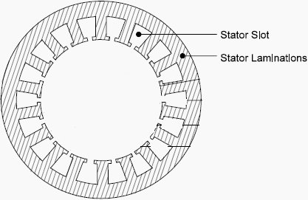

# Fig. 1. Stator lamination

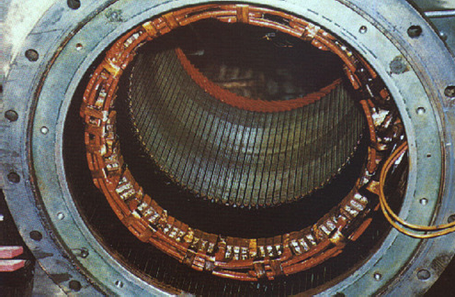 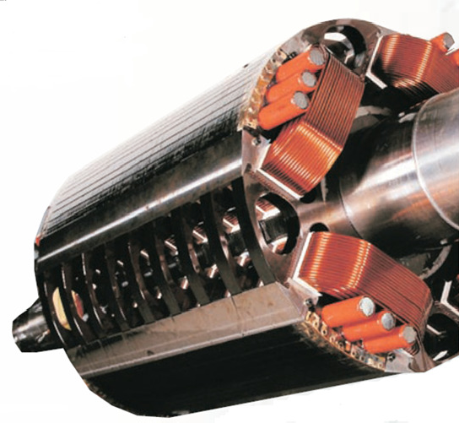

# Fig 2. (a) Stator and (b) rotor of a salient pole alternator

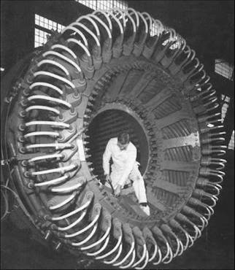

Fig 3. (a) Stator of a salient pole alternator

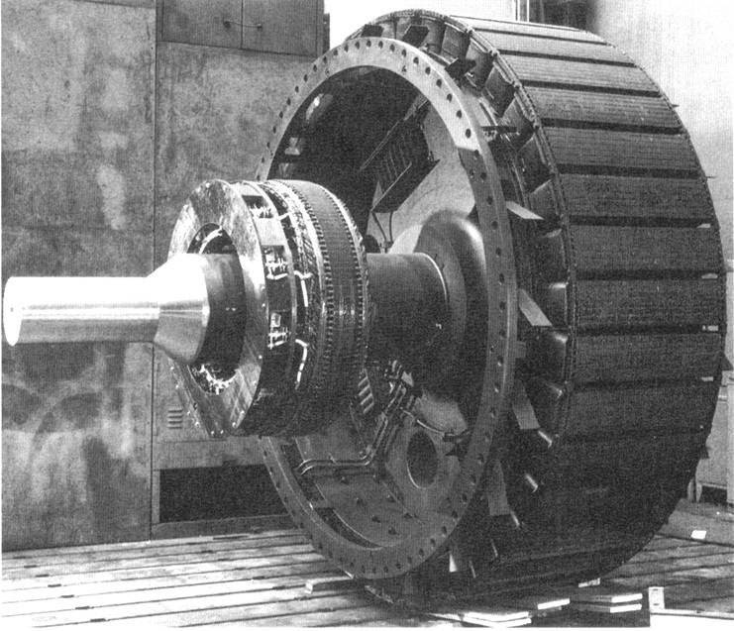

Fig 4. Rotor of a salient pole alternator

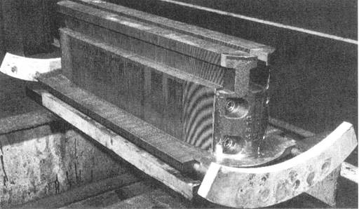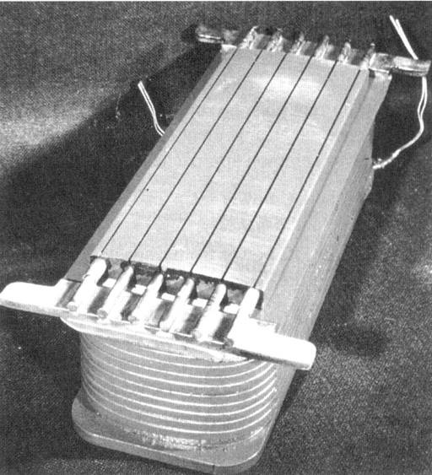

(a ) (b)

Fig 5. (a) Pole body (b) Pole with field coils of a salient pole alternator

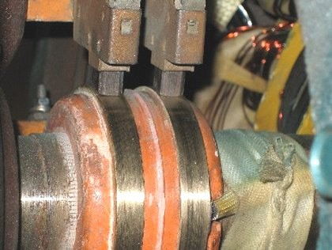

Fig 6. Slip ring and Brushes

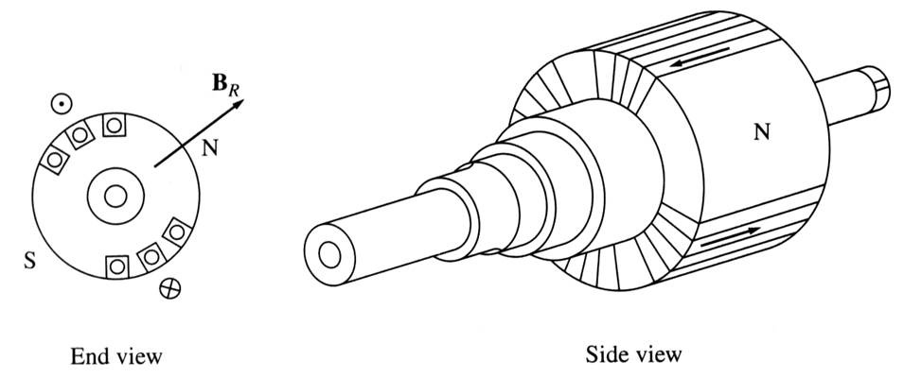

Fig 7. Rotor of a Non salient pole alternator

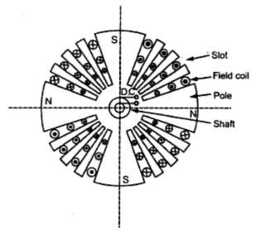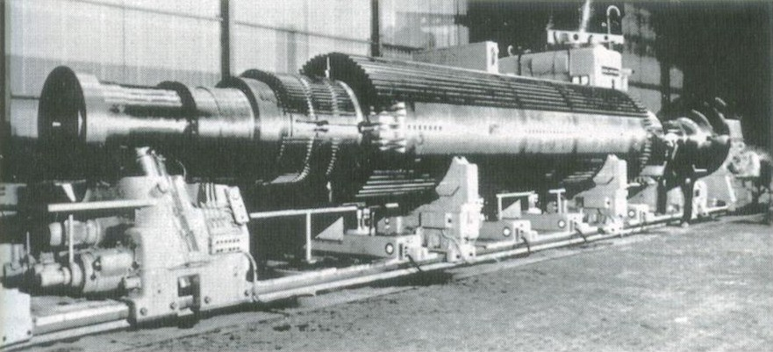

Fig 8. Rotor of a Non salient pole alternator

Rotor of water wheel generator consists of salient poles. Poles are built with thin silicon steel laminations of 0.5mm to 0.8 mm thickness to reduce eddy current laminations. The laminations are clamped by heavy end plates and secured by studs or rivets. For low speed rotors poles have the bolted on construction for the machines with little higher peripheral speed poles have dove tailed construction as shown in Figs. Generally rectangular or round pole constructions are used for such type of alternators. However the round poles have the advantages over rectangular poles.

Generators driven by water wheel turbines are of either horizontal or vertical shaft type. Generators with fairly higher speeds are built with horizontal shaft and the generators with higher power ratings and low speeds are built with vertical shaft design. Vertical shaft generators are of two types of designs (i) Umbrella type where in the bearing is mounted below the rotor. (ii) Suspended type where in the bearing is mounted above the rotor.

In case of turbo alternator the rotors are manufactured form solid steel forging. The rotor is slotted to accommodate the field winding. Normally two third of the rotor periphery is slotted to accommodate the winding and the remaining one third unslotted portion acts as the pole. Rectangular slots with tapering teeth are milled in the rotor. Generally rectangular aluminum or copper strips are employed for filed windings. The field windings and the overhangs of the field windings are secured in place by steel retaining rings to protect against high centrifugal forces. Hard composition insulation materials are used in the slots which can with stand high forces, stresses and temperatures. Perfect balancing of the rotor is done for such type of rotors.

Damper windings are provided in the pole faces of salient pole alternators. Damper windings are nothing but the copper or aluminum bars housed in the slots of the pole faces. The ends of the damper bars are short circuited at the ends by short circuiting rings similar to end rings as in the case of squirrel cage rotors. These damper windings are serving the function of providing mechanical balance; provide damping effect, reduce the effect of over voltages and damp out hunting in case of alternators. In case of synchronous motors they act as rotor bars and help in self starting of the motor.

## Relative dimensions of Turbo and water wheel alternators:

Turbo alternators are normally designed with two poles with a speed of 3000 rpm for a 50 Hz frequency. Hence peripheral speed is very high. As the diameter is proportional to the peripheral speed, the diameter of the high speed machines has to be kept low. For a given volume of the machine when the diameter is kept low the axial length of the machine increases. Hence a turbo alternator will have small diameter and large axial length.

However in case of water wheel generators the speed will be low and hence number of poles required will be large. This will indirectly increase the diameter of the machine. Hence for a given volume of the machine the length of the machine reduces. Hence the water wheel generators will have large diameter and small axial length in contrast to turbo alternators.

## Introduction to Design

Synchronous machines are designed to obtain the following informations.

* + 1. Main dimensions of the stator frame.
    2. Complete details of the stator windings.
    3. Design details of the rotor and rotor winding.
    4. Performance details of the machine.

To proceed with the design and arrive at the design information the design engineer needs the following information.

1. Specifications of the synchronous machine.
2. Information regarding the choice of design parameters.
3. Knowledge on the availability of the materials.
4. Limiting values of performance parameters.
5. Details of Design equations.

## Specifications of the synchronous machine:

Important specifications required to initiate the design procedure are as follows:

Rated output of the machine in kVA or MVA, Rated voltage of the machine in kV, Speed, frequency, type of the machine generator or motor, Type of rotor salient pole or non salient pole, connection of stator winding, limit of temperature, details of prime mover etc.

## Main Dimensions:

Internal diameter and gross length of the stator forms the main dimensions of the machine. In order to obtain the main dimensions it is required to develop the relation between the output and the main dimensions of the machine. This relation is known as the output equation.

## Output Equation:

Output of the 3 phase synchronous generator is given by Output of the machine Q = 3Vph Iph x 10-3 kVA Assuming Induced emf Eph = Vph

Output of the machine Q = 3Eph Iph x 10-3 kVA

Induced emf Eph = 4.44 f Φ TphK**w**

= 2.22 f ΦZphK**w**

Frequency of generated emf f = PNS/120 = Pns/2,

Air gap flux per pole Φ = BavπDL/p, and Specific electric loading q = 3Iph Zph/ πD Output of the machine Q = 3 x (2.22 x Pns/2 x BavπDL/p x Zphx Kw) Iph x 10-3 kVA Output Q = (1.11 x BavπDL x ns x Kw ) (3 x IphZph ) x 10-3 kVA

Substituting the expressions for Specific electric loadings Output Q = (1.11 x BavπDL x ns x Kw ) (πD q ) x 10-3 kVA

Q = (1.11 π2 D2L Bav q Kw ns x 10-3) kVA

Q = (11 Bav q Kw x 10-3) D2L ns kVA Therefore Output Q = Co D2Lns kVA

or D2L = Q/ Cons m3

where Co **=** (11 Bav q Kw x 10-3)

Vph = phase voltage ; Iph = phase current Eph = induced emf per phase

Zph = no of conductors/phase in stator Tph = no of turns/phase

Ns = Synchronous speed in rpm ns = synchronous speed in rps

p = no of poles, q = Specific electric loading Φ = air gap flux/pole; Bav = Average flux density kw = winding factor

From the output equation of the machine it can be seen that the volume of the machine is directly proportional to the output of the machine and inversely proportional to the speed of the machine. The machines having higher speed will have reduced size and cost. Larger values of specific loadings smaller will be the size of the machine.

Choice of Specific loadings: From the output equation it is seen that choice of higher value of specific magnetic and electric loading leads to reduced cost and size of the machine.

Specific magnetic loading: Following are the factors which influences the performance of the machine.

1. Iron loss: A high value of flux density in the air gap leads to higher value of flux in the iron parts of the machine which results in increased iron losses and reduced efficiency.
2. Voltage: When the machine is designed for higher voltage space occupied by the insulation becomes more thus making the teeth smaller and hence higher flux density in teeth and core.
3. Transient short circuit current: A high value of gap density results in decrease in leakage reactance and hence increased value of armature current under short circuit conditions.
4. Stability: The maximum power output of a machine under steady state condition is indirectly proportional to synchronous reactance. If higher value of flux density is used it leads to smaller number of turns per phase in armature winding. This results in reduced value of leakage reactance and hence increased value of power and hence increased steady state stability.
5. Parallel operation: The satisfactory parallel operation of synchronous generators depends on the synchronizing power. Higher the synchronizing power higher will be the ability of the machine to operate in synchronism. The synchronizing power is inversely proportional to the synchronous reactance and hence the machines designed with higher value air gap flux density will have better ability to operate in parallel with other machines.

Specific Electric Loading: Following are the some of the factors which influence the choice of specific electric loadings.

1. Copper loss: Higher the value of q larger will be the number of armature of conductors which results in higher copper loss. This will result in higher temperature rise and reduction in efficiency.
2. Voltage: A higher value of q can be used for low voltage machines since the space required for the insulation will be smaller.
3. Synchronous reactance: High value of q leads to higher value of leakage reactance and armature reaction and hence higher value of synchronous reactance. Such machines will have poor voltage regulation, lower value of current under short circuit condition and low value of steady state stability limit and small value of synchronizing power.
4. Stray load losses: With increase of q stray load losses will increase.

Values of specific magnetic and specific electric loading can be selected from Design Data Hand Book for salient and nonsalient pole machines.

**Separation of D and L:** Inner diameter and gross length of the stator can be calculated from D2L product obtained from the output equation. To separate suitable relations are assumed between D and L depending upon the type of the generator.

Salient pole machines: In case of salient pole machines either round or rectangular pole construction is employed. In these types of machines the diameter of the machine will be quite larger than the axial length.

Round Poles: The ratio of pole arc to pole pitch may be assumed varying between 0.6 to 0.7 and pole arc may be taken as approximately equal to axial length of the stator core. Hence

Axial length of the core/ pole pitch = L/τp = 0.6 to 0.7

Rectangular poles: The ratio of axial length to pole pitch may be assumed varying between 0.8 to 3 and a suitable value may be assumed based on the design specifications.

Axial length of the core/ pole pitch = L/τp = 0.8 to 3

Using the above relations D and L can be separated. However once these values are obtained diameter of the machine must satisfy the limiting value of peripheral speed so that the rotor can withstand centrifugal forces produced. Limiting values of peripheral speeds are as follows:

Bolted pole construction = 45 m/s Dove tail pole construction = 75 m/s Normal design = 30 m/s

Turbo alternators: These alternators will have larger speed of the order of 3000 rpm. Hence the diameter of the machine will be smaller than the axial length. As such the diameter of the rotor is limited from the consideration of permissible peripheral speed limit. Hence the internal diameter of the stator is normally calculated based on peripheral speed. The peripheral speed in case of turbo alternators is much higher than the salient pole machines. Peripheral speed for these alternators must be below 175 m/s.

## Short Circuit Ratio:

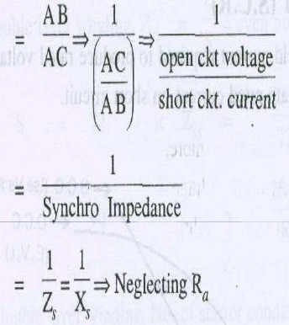

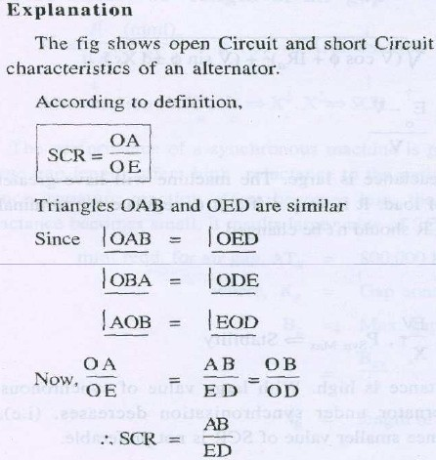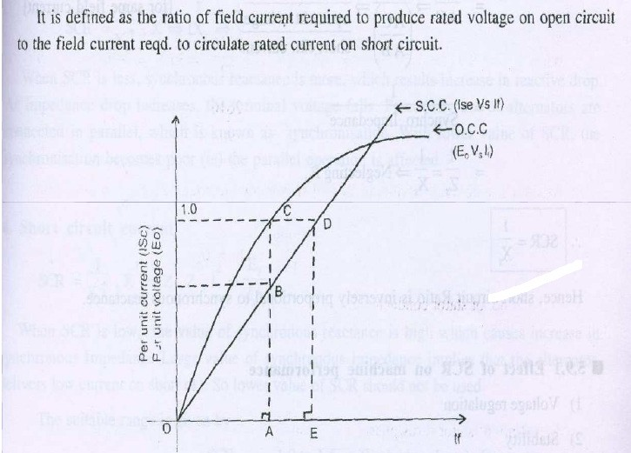

Effect of SCR on Machine performance

1. Voltage regulation
2. Stability
3. Parallel operation
4. Short circuit Current
5. Cost and size of the machine

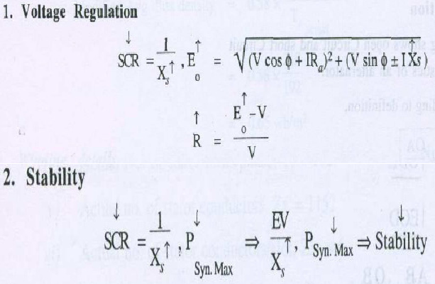

3. Parallel operation: SCR = 1/ Xs, as SCR↑ Xs ↓ IXs ↑ V ↓ Psync ↓

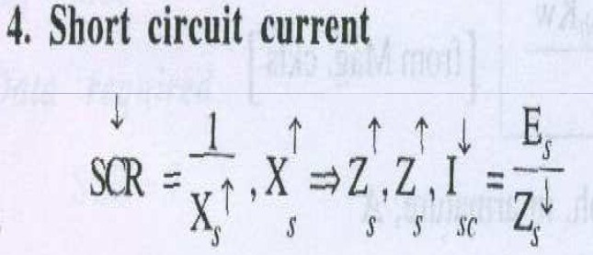

5. Size and cost of the machine

as SCR ↓ Xs ↑ Zs ↑ Isc ↓ and hence cost of control equipment reduces

For salient pole machines SCR value varies from 0.9 to 1.3 For turbo alternators SCR value varies from 0.7 to 1.1

## Length of the air gap:

Length of the air gap is a very important parameter as it greatly affects the performance of the machine. Air gap in synchronous machine affects the value of SCR and hence it influences many other parameters. Hence, choice of air gap length is very critical in case of synchronous machines. Following are the advantages and disadvantages of larger air gap.

Advantages:

1. Stability: Higher value of stability limit
2. Regulation: Smaller value of inherent regulation
3. Synchronizing power: Higher value of synchronizing power
4. Cooling: Better cooling
5. Noise: Reduction in noise
6. Magnetic pull: Smaller value of unbalanced magnetic pull Disadvantages:
7. Field mmf: Larger value of field mmf is required
8. Size: Larger diameter and hence larger size
9. Magnetic leakage: Increased magnetic leakage
10. Weight of copper: Higher weight of copper in the field winding
11. Cost: Increase over all cost.

Hence length of the air gap must be selected considering the above factors.

Calculation of Length of air Gap: Length of the air gap is usually estimated based on the ampere turns required for the air gap.

Armature ampere turns per pole required ATa = 1.35 Tphkw /p

Where Tph = Turns per phase, Iph = Phase current, kw = winding factor, p = pairs of poles No load field ampere turns per pole ATfo = SCR x Armature ampere turns per pole

ATfo = SCR x ATa Suitable value of SCR must be assumed.

Ampere turns required for the air gap will be approximately equal to 70 to 75 % of the no load field ampere turns per pole.

ATg = (0.7 to 0.75) ATfo

Air gap ampere turns ATg = 796000 Bgkg*l*g

Air gap coefficient or air gap contraction factor may be assumed varying from 1.12 to 1.18.

As a guide line, the approximate value of air gap length can be expressed in terms of pole pitch For salient pole alternators: *l*g = (0.012 to 0.016) x pole pitch

For turbo alternators: *l*g = (0.02 to 0.026) x pole pitch

Synchronous machines are generally designed with larger air gap length compared to that of Induction motors.

## Design of stator winding:

Stator winding is made up of former wound coils of high conductivity copper of diamond shape. These windings must be properly arranged such that the induced emf in all the phases of the coils must have the same magnitude and frequency. These emfs must have same wave shape and be displaced by 1200 to each other. Single or double layer windings may be used depending on the requirement. The three phase windings of the synchronous machines are always connected in star with neutral earthed. Star connection of windings eliminates the 3rd harmonics from the line emf.

Double layer winding: Stator windings of alternators are generally double layer lap windings either integral slot or fractional slot windings. Full pitched or short chorded windings may be employed. Following are the advantages and disadvantages of double layer windings.

Advantages:

1. Better waveform: by using short pitched coil
2. Saving in copper: Length of the overhang is reduced by using short pitched coils
3. Lower cost of coils: saving in copper leads to reduction in cost
4. Fractional slot windings: Only in double layer winding, leads to improvement in waveform Disadvantages:
5. Difficulty in repair: difficult to repair lower layer coils
6. Difficulty in inserting the last coil: Difficulty in inserting the last coil of the windings
7. Higher Insulation: More insulation is required for double layer winding
8. Wider slot opening: increased air gap reluctance and noise

## Number of Slots:

The number of slots are to be properly selected because the number of slots affect the cost and performance of the machine. There are no rules for selecting the number of slots. But looking into the advantages and disadvantages of higher number of slots, suitable number of slots per pole per phase is selected. However the following points are to be considered for the selection of number of slots.

(a) Advantages:

1. Reduced leakage reactance
2. Better cooling
3. Decreased tooth ripples

Disadvantages:

1. Higher cost
2. Teeth becomes mechanically weak
3. Higher flux density in teeth
4. Slot loading must be less than 1500 ac/slot
5. Slot pitch must be with in the following limitations
6. Low voltage machines ≤ 3.5 cm
7. Medium voltage machines up to 6kV ≤ 5.5 cm

(iv) High voltage machines up to 15 kV ≤ 7.5 cm

Considering all the above points number of slots per pole phase for salient pole machines may be taken as 3 to 4 and for turbo alternators it may be selected as much higher of the order of 7 to 9 slots per pole per phase In case of fractional slot windings number of slots per pole per phase may be selected as fraction 3.5.

## Turns per phase:

Turns per phase can be calculated from emf equation of the alternator.

Induced emf Eph = 4.44 f Φ TphK**w** Hence turns per phase Tph = Eph / 4.44 f ΦK**w**

Eph = induced emf per phase

Zph = no of conductors/phase in stator Tph = no of turns/phase

kw = winding factor may assumed as 0.955

**Conductor cross section:** Area of cross section of stator conductors can be estimated from the stator current per phase and suitably assumed value of current density for the stator windings.

Sectional area of the stator conductor as = Is **/** δs where δs is the current density in stator windings Is is stator current per phase

A suitable value of current density has to be assumed considering the advantages and disadvantages. Advantages of higher value of current density:

1. reduction in cross section
2. reduction in weight
3. reduction in cost

Disadvantages of higher value of current density

1. increase in resistance
2. increase in cu loss
3. increase in temperature rise
4. reduction in efficiency

Hence higher value is assumed for low voltage machines and small machines. Usual value of current density for stator windings is 3 to 5 amps/mm2.

## Stator coils:

Two types of coils are employed in the stator windings of alternators. They are single turn bar coils and multi turn coils. Comparisons of the two types of coils are as follows

1. Multi turn coil winding allows greater flexibility in the choice of number of slots than single turn bar coils.
2. Multi turn coils are former wound or machine wound where as the single turn coils are hand made.
3. Bending of top coils is involved in multi turn coils where as such bends are not required in single turn coils.
4. Replacing of multi turn coils difficult compared to single turn coils.
5. Machine made multi turn coils are cheaper than hand made single turn coils.
6. End connection of multi turn coils are easier than soldering of single turn coils.
7. Full transposition of the strands of the single turn coils are required to eliminate the eddy current loss.
8. Each turn of the multi turn winding is to be properly insulated thus increasing the amount of insulation and reducing the space available for the copper in the slot.

From the above discussion it can be concluded that multi turn coils are to be used to reduce the cost of the machine. In case of large generators where the stator current exceeds 1500 amps single turn coils are employed.

## Single turn bar windings:

The cross section of the conductors is quite large because of larger current. Hence in order to eliminate the eddy current loss in the conductors, stator conductors are to be stranded. Each slot of the stator conductor consists of two stranded conductors as shown in **Fig XXX.** The dimensions of individual strands are selected based on electrical considerations and the manufacturing requirements. Normally the width of the strands is assumed between 4 mm to 7 mm. The depth of the strands is limited based on the consideration of eddy current losses and hence it should not exceed 3mm. The various strand of the bar are transposed in such a way as to minimize the circulating current loss.

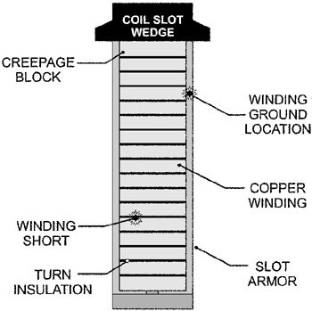

## Fig XXX

**Multi turn coils:**

Multi turn coils are former wound. These coils are made up of insulated high conductivity copper conductors. Mica paper tape insulations are provided for the portion of coils in the slot and varnished mica tape or cotton tape insulation is provide on the over hang portion. The thickness of insulation is decided based on the voltage rating of the machine. Multi turn coils are usually arranged in double layer windings in slots as shown in Fig XXX.

Lip Wedge Top liner Slot liner

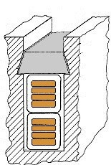

Coil insulation Coil separator Cond. insulation Conductor

Fig. XXX

## Dimensions of stator slot:

Width of the slot = slot pitch – tooth width

The flux density in the stator tooth should not exceed 1.8 to 2.0 Tesla. In salient pole alternators internal diameter is quite large and hence the flux density along the depth of the tooth does not vary appreciably. Hence width of the tooth may be estimated corresponding to the permissible flux density at the middle section of the tooth. The flux density should not exceed 1.8 Tesla. However in case of turbo alternators variation of flux density along the depth of the slot is appreciable and hence the width of the tooth may be estimated corresponding to the flux density at the top section of the tooth or the width of the tooth at the air gap. The flux density at this section should not exceed 1.8 Tesla.

For salient pole alternator:

Flux density at the middle section =

Flux / pole /( width of the tooth at the middle section x iron length x number of teeth per pole arc) Number of teeth per pole arc = pole arc/slot pitch

For turbo alternators:

Flux density at the top section =

Flux / pole /( width of the tooth at the top section x iron length x number of teeth per pole pitch) As the 2/3rd pole pitch is slotted the number of teeth per pole pitch =

2/3 x pole pitch/( slot pitch at top section) Slot width = slot pitch at the top section – tooth width at the top section.

Once the width of the slot is estimated the insulation required width wise and the space available for conductor width wise can be estimated.

Slot insulation width wise:

1. Conductor insulation
2. Mica slot liner
3. Binding tape over the coil
4. Tolerance or clearance

Space available for the conductor width wise = width of the slot – insulation width wise

We have already calculated the area of cross section of the conductor. Using above data on space available for the conductor width wise depth of the conductor can be estimated. Now the depth of the slot may be estimated as follows.

Depth of the slot:

1. Space occupied by the conductor = depth of each conductor x no. of conductor per slot
2. Conductor insulation
3. Mica slot liner
4. Mica or bituminous layers to separate the insulated conductors
5. Coil separator between the layers
6. Wedge
7. Lip
8. Tolerance or clearance

## Mean length of the Turn:

The length of the mean turn depends on the following factors

1. Gross length of the stator core: Each turn consists of two times the gross length of stator core.
2. Pole pitch: The over hang portion of the coils depend upon the coil span which in turn depends upon the pole pitch.
3. Voltage of the machine: The insulated conductor coming out of the stator slot should have straight length beyond the stator core which depends upon the voltage rating of the machine.
4. Slot dimension: Length per turn depends on the average size of the slot.

Hence mean length of the turn in double layer windings of synchronous machines is estimated as follows.

*lmt = 2l + 2.5* τ*p+ 5 kV* + 15 cm

## Numerical Problems:

**Ex. 1** Design the stator frame of a 500 kVA, 6.6 kV, 50 Hz, 3 phase, 12 pole, star connected salient pole alternator, giving the following informations.

1. Internal diameter and gross length of the frame
2. Number of stator conductors
3. Number of stator slots and conductors per slot

Specific magnetic and electric loadings may be assumed as 0.56 Tesla and 26000 Ac/m respectively. Peripheral speed must be less than 40 m/s and slot must be less than 1200.

Soln:

1. Diameter and gross length of stator: Assuming the winding to be full pitched Kw = 0.955 Output coefficient Co = 11 x Bav q Kw x 10-3

= 11 x 0.56 x 26000 x 0.955 x 10-3

= 153

Speed in rps ns = 2f/p = 2 x 50/12

= 8.33 rps Output Q = C0 D2Lns =

D2L = Q / C0 ns = 500/( 153 x 8.33)

= 0.392 m3

Using round poles for the salient pole alternator and assuming ratio of pole arc to pole pitch as

0.65 and pole arc equal to core length

Pole arc/ pole pitch = core length/ pole pitch = 0.65 L = πD/p = πD/12

L = 0.17D

Substituting this relation in D2L product and solving for D and L D = 1.32 m and L = 0.225 m.

Peripheral speed = πDns m/s

= π x 1.32 x 8.33

= 34.6 m/s (with in limitations)

1. Number of stator conductors Eph = 6600/√3 = 3810 volts

Air gap flux per pole = Bav x πDL/p

= 0.56 x π x 1.32 x 0.225/12

= 0.0436 wb

We have Eph = 4.44f Φ Tph Kw

Hence Tph = 3810/ ( 4.44 x 50 x 0.955 x 0.0436)

= 412

Total number of stator conductors/phase = 412 x 2 =824 conductors Total number of conductors = 412 x 6 = 2472

1. Number of stator slots and conductors per slot Considering the guide lines for selection of number of slots Selecting the number of slots/pole/phase = 3

Total number of slots = 3 x 12 x 3 =108

Slot pitch = πD/S

= π x 132/ 108

= 2.84 cm (quite satisfactory)

Number of conductors per slot = 2472/108

≈ 24

Hence total number of conductors = 24 x 108 = 2592 Turns per phase = 2592/6 = 432

Slot loading:

Full load current = 500 x 103 / (√3 x 6600)

= 43.7 amps

Slot loading = current per conductor x number of conductors/ slot

= 43.7 x 24

= 1048.8 ( satisfactory)

**Ex. 2**. A 3 phase 1800 kVA, 3.3 kV, 50 Hz, 250 rpm, salient pole alternator has the following design data.

Stator bore diameter = 230 cm Gross length of stator bore = 38 cm Number of stator slots = 216 Number of conductors per slot = 4

Sectional area of stator conductor = 86 mm2 Using the above data, calculate

* 1. Flux per pole
  2. Flux density in the air gap
  3. Current density
  4. Size of stator slot

## Soln:

1. Flux per pole

Eph = 3300/√3 = 1905 volts

Number of slots per phase 216/3 = 72 Number of conductors per slot = 4

Total number of conductors per phase = 72 x 4 = 288 Number of turns per phase Tph = 288/2 =144

We have from emf equation Eph = 4.44f Φ Tph Kw Assuming Kw =0.955

Flux per pole Φ = Eph/ (4.44f Tph Kw)

= 1905/( 4.44 x 50 x 144 x 0.955)

= 0.0624 wb

1. Flux density in the air gap

Air gap flux per pole = **Bav** x πDL/p D = 230 cm,

L = 38 cm,

Ns = 250 rpm P = 24

Bav = Φ / πDL/p

= 0.0624 x 24 / (π x 2.3 x 0.38)

= 0.55 Tesla

1. Current density

Sectional area of the conductor = 86 mm2

Full load current of the machine = 1800 x 103 / (√3x 3300)

= 314.9 amps Hence Current density = 314.9/86

= 3.7 amp/mm2

1. Size of the stator slot

Before fixing up the width of the slot flux density in the middle section of the tooth has to be assumed as 1.7 Tesla. Based on this flux density width of the slot at the middle section can be found.

Flux per pole = 0.0624 wb Gross length of the core = 38 cm Assume

Number of ventilating duct = 4 Width of the ventilating duct = 1cm Iron space factor =0.92

Net iron length of the core *li =( L – nd* x *wd)ki*

= ( 38 – 4 x 1) 0.92

= 31.28 cm

Pole pitch = πD/p

= π x 230/24

= 30.12 cm

Pole arc/ pole pitch = 0.65 ( Assumed) Pole arc = 0.65 x pole pitch

= 0.65 x 30.12

= 19.6 cm

Number of stator teeth = 216 Slot pitch = πD/s

= π x 230/216

= 3.35 cm

Number of teeth per pole arc = pole arc/ slot pitch

= 19.6/3.35

= 6

Flux density in stator teeth = flux per pole /( bt x *li* x number of teeth per pole arc) bt = 0.0624/( 1.7 x 0.3128 x 6)

= 1.95 cm

Thus the width of the slot should not exceed = 3.35 – 1.95

= 1.4 cm

|  |  |  |
| --- | --- | --- |
| Slot insulation width wise: |  | |
| (i) Conductor insulation | 2 x 0.5 | = 1.0 mm |
| (ii) Micanite slot liner | 2 x 1.5 | = 3.0 mm |
| (iii) Binding tape | 2 x 0.4 | = 0.8 mm |
| (iv) tolerence |  | = 1.2 mm |

Total = 6.0 mm

Maximum space available for the conductor width wise = width of the slot – insulation width wise

= 1.4 – 0.6

= 0.8 cm

Area of cross section of the conductor = 86 mm2 Hence thickness of the conductor = 86/8 = 10.75 mm

Hence the dimension of the standard conductor selected = 7.8 mm x 11.0 mm Hence the width of the conductor = 7.8 + 6.0 = 13.8 mm =1.38 cm

Arrangement of the conductor:

All the four conductors are arranged depth wise

Depth of the slot:

* 1. Space occupied by the conductor 4 x 11 = 44.0 mm
  2. Conductor insulation 4 x 2 x 0.5 = 4.0 mm
  3. Micanite slot liner 2 x 1.5 = 3.0 mm (iv)Bituminous insulation between the

insulated conductors (4-1) x 0.2 = 0.6 mm (v)Binding tape on the conductors 2 x 0.4 = 0.8 mm

1. Lip = 1.5 mm
2. Wedge = 3.5 mm
3. Tolerance = 1.6 mm

Total 59 mm

Size of the slot = 1.38 cm x 5.9 cm

**Ex.3.** A water wheel generator with power output of 4750 kVA, 13.8 kV, 50 Hz, 1000 rpm, working at a pf of 0.8 has a stator bore and gross core length of 112 cm and 98 cm respectively. Determine the loading constants for this machine.

Using the design constants obtained from the above machine determine the main dimensions of the water wheel generator with 6250 kVA, 13.8 kV, 50 Hz, 750 rpm operating at a power factor of

0.85. Also determine (i) Details of stator winding (ii) Size of the stator slot, (iii) Copper losses in the stator winding.

For 4750 kVA Generator:

D = 112 cm

L = 98 cm

Ns = 1000 rpm

Ns = 1000/60 = 16.67 rps

kVA out put Q = C0 D2Lns

C0 = Q / D2Lns

= 4750 / [(1.12)2 x 0.98 x 16.67]

= 232

Output coefficient Co = 11 x Bav q Kw x 10-3 Hence Bav x q = Co / (11 x Kw x 10-3)

= 232 / (11 x 0.955 x 10-3)

= 22200

Assuming the flux density of 0.6 Tesla Hence q = 22200/0.6 = 37000 Ac/m

## Main Dimensions of the second machine:

kVA out put Q = C0 D2Lns C0 = 232

Q = 6250 kVA

Ns = 750 rpm

Ns = 750/60 = 12.5 rps

D2L = Q / C0 ns

= 6250 / 232 x 12.5

= 2.16 m3

For the first machine pole pitch τp = πD/p

= π x 112/6

= 58.6 cm

Core length / pole pitch = gross length/ pole pitch

= 98/58.6

= 1.67

No. of poles for the second machine p = 120f/Ns= 120 x 50 / 750 = 8

Assuming the same ratio of gross length to pole pitch for the second machine as that of first machine

We have D2L = 2.16 m3

L / πD/p = 1.67 L = 1.67 x πD/8

= 0.655 D

Substituting the value of L in D2L and solving for D & L D = 149 cm and L = 97.5 cm

Peripheral speed for machine 1: πDNs /60 = π x 1.12 x 1000/60 = 58.5 m/s

Peripheral speed for machine 2: πDNs /60 = π x 1.49 x 750/60 = 58.5 m/s

As the peripheral speed is same for both the machines the diameter and length of the machine are satisfactory.

Stator winding details:

Assuming star connection emf per phase Eph = 13.8/√3 = 7960 volts We have from emf equation Eph = 4.44f Φ Tph Kw

Assuming Kw =0.955, f = 50 Hz Air gap flux per pole 8 = Bav x πDL/p

Assuming the air gap flux density of machine 2 same as that of machine 1 Bav = 0.6 Tesla Hence 8 = Bav x πDL/p = 0.6 x π x 1.49 x 0.975/ 8 = 0.342 wb

Hence Tph = Eph/4.44f Φ Kw

= 7960/ (4.44 x 50 x 0.342 x 0.955)

= 110

Total number of Conductors =110 x 6 = 660

Full load current per phase Iph = 6250 x 103 / √3 x 13.8 x 103

= 262 amps Assuming number of slots per pole per phase = 4 1/2 Total number of slots = 4.5 x 8 x 3 = 108

Slot pitch = πD/s = π x 149/108 = 4.35 cm ( quite satisfactory)

Number of conductors per slot = 660/108 ≈ 6

Total number of conductors revised = 108 x 6 = 648 Number of turns/phase = 108

Total slot loading = Iph x Cond/slot

= 262 x 6 = 1572 amp cond (quite satisfactory)

Dimension of the stator slot:

Full load current per phase Iph = 6250 x 103 / √3 x 13.8 x 103

= 262 amps Assuming a current density of 4.2 amps/mm2

Area of cross section of the conductor = 262/4.2 = 62.4 mm2

Based on the allowable flux density, width of the stator tooth can be calculated and then the width of the slot can be estimated.

Flux density in stator tooth Bt = 8 / (Number of teeth/pole arc x width of the teeth x Iron length)

In a large salient pole alternator the flux density in the tooth along the depth of the tooth does not vary appreciably. Thus the flux density at the top of the tooth may be assumed as 1.7 Tesla and the width of the tooth is calculated at the top section.

Hence number of teeth per pole arc = pole arc/ slot pitch Assuming pole arc/ pole pitch = 0.65

Pole arc = 0.65 x 58.6 = 38.1 cm

Thus the number of teeth per pole arc = 38.1/4.35 = 9

Net Iron length = (L – ndwd) ki

Assuming 10 ventilating ducts of each 1 cm width and an iron space factor of 0.92

*Li* = (97.5 -10 x 1)0.92 = 80.5 cm = 0.805 m

*Bt* = 8 / (Number of teeth/pole arc x x *Li*)

= 0.342/ ( 9 x bt x 0.805)

Assuming the flux density Bt as 1.7 Tesla

Hence width of the teeth = 2.78 cm We have the slot pitch = 4.35 cm

Thus the slot pitch = 4.35 – 2.78 = 1.55 cm

|  |  |  |
| --- | --- | --- |
| Slot insulation width wise:  Slot insulation width wise: |  | |
| (i) Conductor insulation | 2 x 0.5 | = 1.0 mm |
| (ii) Micanite slot liner | 2 x 1.5 | = 3.0 mm |
| (iii) Binding tape | 2 x 0.25 | = 0.5 mm |
| (iv) tolerence |  | = 1.0 mm |
|  | Total | = 5.5 mm |

|  |  |  |
| --- | --- | --- |
| Insulation depth wise: |  | |
| (i) Conductor insulation | 6 x 2 x 0.5 | = 6.0 mm |
| (ii) Micanite slot liner | 2 x 1.5 | = 3.0 mm |
| (iii)Bituminous insulation between the |  |  |
| insulated conductors | (6-1) x 0.3 | = 1.5 mm |
| (iv) coil separator between layers |  | = 0.4 mm |
| (iv)Binding tape on the conductors | 6 x 2 x 0.25 | = 3.0 mm |
| (v) Lip |  | = 1.0 mm |
| (vi) Wedge |  | = 3.0 mm |
| (vii) Tolerance |  | = 1.6 mm |

Total 19.5 mm

Maximum space available for the conductor width wise = width of the slot – insulation width wise

= 1.55 – 0.55

= 1.0 cm

The area of cross section of the conductor = 62.4 mm2 Approximate depth of the conductor = 62.4/ 10 = 6.2 mm Selecting the standard conductor of size 9 mm x 7 mm Thus the area of the conductor = 63 mm2

Six conductors are arranged as 3 conductors depth wise in two layers.

Hence width of the slot = 9 mm + 5.5 mm = 14.5 mm = 1.45 cm Depth of the slot = 6 x 7 + 19.5 mm = 61.5 mm =6.15 cm

Copper loss in stator winding

Approximate length of the mean turn = ( 2L + 2.5 τp + 5 x kV + 15)

= ( 2 x 97.5 + 2.5 x 58.6 + 5 x 13.8 + 15)

= 426 cm

= 4.26 m

Resistance of the stator winding = ζ x *lmt* x Tph /a

= 0.021 x 4.26 x 108 / 63

= 0.153 ohm

Total Copper losses = 3 I2R

= 3 x (262)2 x 0.153

= 31500 watts

**Ex. 4.** Two preliminary designs are made for a 3 phase alternator, the two designs differing only in number and size of the slots and the dimensions of the stator conductors. The first design uses two slots per pole per phase with 9 conductors per slot, each slot being 75 mm deep and 19 mm wide, the mean width of the stator tooth is 25 mm. The thickness of slot insulation is 2 mm, all other insulation may be neglected. The second design is to have 3 slots per pole per phase. Retaining the same flux density in the teeth and current density in the stator conductors as in the first design, calculate the dimensions of the stator slot for the second design. Total height of lip and wedge may be assumed as 5 mm.

## Slon.

**First Design:**

Slot per pole per phase q = 2

Total height of the conductor = 75 – 5 – 2 x 2 = 66 mm Height of each conductor = 66/9 = 7.33 mm

Width of each conductor = 19 -2 x 2 = 15 mm Area of each conductor = 7.33 xx 15 = 110 mm2

Slot pitch at mean diameter = slot width + tooth width = 19 + 25 = 44 mm

## Second Design:

Slots per pole per phase = 3

Hence, the number of stator slots in this design are 3/2 times that in the first design. Retaining the same flux density in the teeth and current density in the stator conductors The number of conductors per slot in this design is 2/3 times that in the first design.

Number of conductors per slot = 2/3 x 9 = 6

Slot pitch at mean diameter = 2/3 x 44 = 29.3 mm

Tooth width at the same flux density = 2/3 x 25 = 16.7 mm Hence slot width = 29.3 -16.7 = 12.6 mm

Width of each conductor = 12.6 – 2 x 2 = 8.6 mm Height of each conductor = 110/8.6 = 12.8 mm Total height of the conductor = 6 x 12.8 = 76.8 mm Conductor dimensions 12.8 x 8.6 mm2

Depth of the slot = 76.8 + 5 + 2 x 2 = 85.8 mm Slot dimensions = 85.8 x 12.6 mm2

**Ex. 5.** A 1000 kVA, 3300 volts, 50 Hz, 300 rpm, 3 phase alternator has 180 slots with 5 conductors per slot. Single layer winding with full pitched coils is used. The winding is star connected with one circuit per phase. Determine the specific electric and magnetic loading if the stator bore is 2 m and core length is 0.4 m. Using the same specific loadings determine the design details for a 1250 kVA, 3300 volts, 50 Hz, 250 rpm, 3 phase star connected alternator having 2 circuits per phase. The machines have 600 phase spread.

**Slon:** Total stator conductors = 180 x 5 =900

Turns per phase **=** 900 / 6 = 150 Synchronous speed =300/60 =5 rps

Number of poles = 120f / Ns = 120 x 50/ 300 = 20 Slots per pole per phase = 180/(20 x 3) = 3 Distribution factor = (sin 60/2) / (3 sin 60/6) = 0.96 For Full pitched winding, pitch factor kp = 1 Winding factor = kp x kd = 0.96

Eph = 3300/√3 =1910 volts

Flux per pole 8 = 1910 / ( 4.44 x 50 x 150 x 0.96) = 59.8 mwb Pole pitch = πD/p = π x 2 / 20 = 0.314 m

Area of one pole pitch Ap = pole pitch x core length = 0.314 x 0.4 = 125.6 x 10-3 m2 Specific magnetic loading = 8 / Ap = 59.8 x 10-3 / 125.6 x 10-3 = 0.476 Tesla

Current per phase Iph = 1000 x 103 / ( 3 x 1910) = 175 amps

As there is one circuit per phase current per conductor = 175 amps

Specific electric loading = 3 Iph zph/ πD = 6 Iph Tph/ πD = 6 x 175 x 150/ (π x 2) = 25000 Ac/m Peripheral speed = πDNs/60 = π x 2 x 300/60 = 31.4 m/s

## 1250 kVA generator

Synchronous speed = 250/60 = 4.167 rps

Number of poles = 120f / Ns = 120 x 50/ 250 = 24 Winding factor = 0.96

Output coefficient C0 = 11 Bav q Kw x 10-3 = 11 x 0.476 x 0.96 x 25000 x 10-3 = 126

D2L = Q/ C0 ns = 1250 / (126 x 4.167) = 2.39 m3

Keeping the peripheral speed same as that of the first machine

πDNs/60 = π x D x 250/60 = 31.4 m/s Hence D = 2.4 m and L 0.414 m

Pole pitch = πD/p = π x 2.4 / 24 = 0.314 m

Flux per pole = Bav x πDL/p = 0.476 x 0.314 x 0.414 = 0.062 wb

When there are more than one circuit per phase ( number of parallel paths = a) Voltage per phase Eph = 4.44f Φ Tph Kw / a; a = 2

Hence Tph = (2 x 1910) / ( 4.44 x 50 x 0.062 x 0.96) = 289

Total number of conductors = 6 Tph = 6 x 289 = 1734

Total number of slots = 3 x 24 x 3 = 216 Number of conductors per slot = 1734/216 ≈ 8 Revised number of conductors = 8 x 216 = 1728

Revised number of turns per phase = 1728/ 6 = 288

**Ex. 6.** Determine the main dimensions of a 75 MVA, 13.8 kV, 50 Hz, 62.5 rpm, 3 phase star connected alternator. Also find the number of stator slots, conductors per slot, conductor area and work out the winding details. The peripheral speed should be less than 40 m/s. Assume average gap density as 0.65 wb/m2, Specific electric loading as 40,000 AC/m and current density as 4 amp/ mm2.

## Slon:

Synchronous speed = 62.5/60 = 1.0417 rps Number of poles = 120f / Ns = 120 x 50/ 62.5 = 96 Winding factor = 0.955

Output coefficient C0 = 11 Bav q Kw x 10-3 = 11 x 0.65 x 0.955 x 40000 x 10-3 = 273 D2L = Q/ C0 ns = 75000 / (273 x 1.0417) = 264 m3

Taking the peripheral speed as 40 m/s Peripheral speed = πDNs/60

Hence D = 40 x 60/ π x 300 = 12.2 m and L = 1.77 m Pole pitch = πD/p = π x 12.2 / 96 = 0.4 m

Flux per pole = Bav x πDL/p = 0.65 x 0. 4 x 1.77 = 0.46 wb Eph = 13800/√3 = 7960 volts

Assuming one circuit per phase

Turns per phase Tph = Eph / 4.44f Φ Kw = 7960 / ( 4.44 x 50 x 0.46 x 0.955) ≈ 82

As the terminal voltage of the machine is 13.8 kV slot pitch of about 5.5 cm should be used. Hence the number of slots = πD / τs = π x 12.2 x 100/5.5 = 696

Number of slots per pole per phase = S/ 3p = 696 / (3 x 96) = 2.42

The above fractional value of slots per pole per phase indicates that fractional slot winding is used. Number of slots and turns per phase must be finalized such that they should not differ significantly from the earlier calculated values.

It is also to be noted that for fractional slot winding double layer winding is a must and hence conductors per slot must be an even.

Assuming number of slots per pole per phase as 2.5 Total number of slots = 2.25 x 3 x 96 = 648

Total number of conductors = 2 x 3 x Tph = 6 x 82 = 492 Hence number of conductors per slot = 492/648 = fraction

Hence a double layer winding is not possible with one circuit per phase. Hence the number of circuits is to be selected in such a way that number of conductors per slot is even and the winding becomes symmetrical.

Taking the number parallel circuits as a = 8

Turns per phase Tph = a x Eph / 4.44f Φ Kw = 8 x 7960 / ( 4.44 x 50 x 0.46 x 0.955) ≈ 654 Hence total number of conductors = 2 x 3 x Tph = 6 x 654 = 3924

Number of conductors per slot = 3924/ 648 ≈ 6 Hence the number of conductors = 6 x 648 = 3888 Hence turns per phase Tph = 3888/6 = 648

Current per phase = (75000 x 103) / ( 3 x 7960) = 3140 amps

Current in each conductor = Current per parallel path = 3140/8 = 392.5 amps Area of cross section of each conductor = 392.5/4 = 98.125 mm2

Area of cross section of conductor being very large conductors are stranded and used.

**Ex.7**. Calculate the stator dimensions for 5000 kVA, 3 phase, 50 Hz, 2 pole alternator. Take mean gap density of 0.5 wb/m2, specific electric loading of 25,000 ac/m, peripheral velocity must not exceed 100 m/s. Air gap may be taken as 2.5 cm.

Soln: Output Q = Co D2Lns kVA Co = 11 Bav q Kw x 10-3 Assuming Kw = 0.955

Co = 11 x 0.5 x 25000 x 0.955 x 10-3

= 130

Ns = 120f/p = 120 x 50/ 2 = 3000

ns = 3000/60 = 50 rps D2L = Q/ Cons

= 5000/(130 x 50)

= 0.766 m3

Peripheral velocity = πDrNs/60

= 100 m/s

Dr = 100/(50 x π)

= 63.5 cm

D = Dr + 2lg

= 63.5 + 2 x 2.5

= 68.5 cm L = 163 cm

Numerical Problems: Turbo alternators

Ex.1. Calculate the stator dimensions for 5000 kVA,

3 phase, 50 Hz, 2 pole alternator. Take mean gap density of 0.5 wb/m2, specific electric loading of 25,000 ac/m, peripheral velocity must not exceed 100 m/s. Air gap may be taken as 2.5 cm.

Soln: Output Q = Co D2Lns kVA

Co = 11 Bav q Kw x 10-3 Assuming Kw = 0.955

Co = 11 x 0.5 x 25000 x 0.955 x 10-3

= 130

Ns = 120f/p = 120 x 50/ 2 = 3000 rpm ns = 3000/60 = 50 rps

D2L = Q/ Cons

= 5000/(130 x 50)

= 0.766 m3

Peripheral velocity = πDrNs/60

= 100 m/s

Dr = 100/(50 x π)

= 63.5 cm

D = Dr + 2lg

= 63.5 + 2 x 2.5

= 68.5 cm L = 163 cm

Ex.2. A 3000 rpm, 3 phase, 50 Hz, turbo alternator Has a core length of 0.94 m. The average gap density

is 0.45 Tesla and the ampere conductors per m are 25000. The peripheral speed of the rotor is 100 m/s and the length of the air gap is 20mm. Find the kVA output of the machine when the coils are (i) full pitched (ii) short chorded by 1/3rd pole pitch. The winding is infinitely distributed with a phase spread of 600.

Soln:

Synchronous speed Ns = 3000 rpm

ns= 3000/60 = 50 rps Peripheral speed np = πDrNs/60

= 100 m/s

Hence diameter of the rotor Dr = 100 x 60 / (π x 3000)

= 0.637 m

Hence inner diameter of stator D = Dr + 2lg

= 0.637 + 2 0.02

= 0.677 m

1. With infinite distribution and 600 phase spread the distribution factor may be given by where

α is the phase spread

Kd = sin σ/2 / σ/2 = sin π/6 / π/6 = 0.955 With full pitched coils Kp = 1

Winding factor = Kp x Kd = 0.955 Output of the machine Q = C0 D2Lns

= 11 Bav q Kw x D2Lns x 10-3

= 11 x 0.45 x 25000 x 0.955 x 0.6672 x 0.94 x 50 x 10-3

= 2480 kVA

1. With chording of 1/3rd of pole pitch: chording angle α = 180/3 =600

Pitch factor = cos α /2 = 0.866

Winding factor = Kp x Kd = 0.955 x 0.866 = 0.827

Output of the machine Q = C0 D2Lns

= 11 Bav q Kw x D2Lns x 10-3

= 11 x 0.45 x 25000 x 0.827 x 0.6672 x 0.94 x 50 x 10-3

= 2147 kVA

Ex. 3. Estimate the stator dimensions, size and number of conductors and number of slots of 15 MVA 11kV,

3 phase, 50 Hz, 2 pole turbo alternator with 600 phase spread.

Assume Specific electric loading = 36000 AC/m, specific magnetic loading = 0.55 Tesla, Current density = 5 Amp/mm2 , peripheral speed = 160 m/s. The winding must be designed to eliminate 5th harmonic.

Soln: Synchronous speed Ns = 120f/p = 120 x 50/ 2 = 3000 rpm

ns= 3000/60 = 50 rps Peripheral speed np = πDrNs/60

= 160 m/s

Hence diameter of the rotor Dr ≈D

= 160 x 60 / (π x 3000)

= 1 m

With a phase spread of 600 distribution factor Kd = sin σ/2 / σ/2 = sin π/6 / π/6 = 0.955

In order to eliminate 5th harmonic chording angle α = 180/5= 360 Pitch factor Kp = cos α /2 = 0.951

Winding factor = Kp x Kd = 0.955 x 0.951 = 0.908 Output coefficient C0 = 11 Bav q Kw x 10-3

= 11 x 0.55 x 36000x 0.908 x10-3

= 198

D2L = Q / C0 ns

= 15 000/ (198 x 50) = 1.51 m3

We have D = 1 m and D2L =1.51 m3 Solving for L, L= 1.51 m

Flux per pole = Bav x πDL/p

= 0.55 x π x 1 x 1.51 / 2

= 1.3 wb

Eph = 1100/√3 =6360 volts Hence Tph = Eph/4.44f Φ Kw

= 6360 / ( 4.44 x 50 x 1.3 x 10-3 x 0.908)

= 24

Total number of conductors = 6 x 24

=144

For the turbo alternator selecting slots/pole/phase = 5

Total number of stator slots = 5 x 2 x 3 = 30

Conductors/slot = 144 /30 = 5

can not use double layer winding, using two circuits per phase conductors/slot = 10

Total conductors 10 x 30 = 300.

## Design of the field System: Salient pole Alternator: Dimension of the pole:

1. Axial Length of the pole: Axial length of the pole may be assumed 1 to 1.5 cm less than that of the stator core.
2. Width of the pole: Leakage factor for the pole is assumed varying between 1.1 to 1.15. Thus the flux in the pole body = 1.1 to 1.15 8

Area of the pole = Flux in the pole body/ Flux density in the pole body. Flux density in the pole body is assumed between 1.4 to 1.6 wb/m2.

Area of the pole = width of the pole x net axial length of the pole.

Net axial length of the pole = gross length x stacking factor Stacking factor may be assumed as 0.93 to 0.95.

Hence width of the pole = Area of the pole / net axial length of the pole.

1. Height of the pole:

Height of the pole is decided based on the mmf to be provided on the pole by the field winding at full load. Hence it is required to find out the mmf to be provided on the pole at full load before finding the height of the pole. Full load field ampere turns required for the pole can be calculated based on the armature ampere turns per pole.

Hence full load field ampere turns per pole can be assumed 1.7 to 2.0 times the armature ampere turns per pole.

Armature ampere turns per pole ATa = 1.35 Iph Tph Kw /p And

ATfl = (1.7 to 2.0) ATa

Height of the pole is calculated based on the height of the filed coil required and the insulation.

Height of the filed coil:

If = current in the field coil

af = area of the field conductor

Tf = number of turns in the field coil Rf = resistance of the field coil

*lmt* = length of the mean turn of the field coil

sf = copper space factor

hf = height of the field coil df = depth of the field coil

pf = permissible loss per m2 of the cooling surface of the field coil

ζ = specific resistance of copper

Watts radiated from the field coil = External surface in cm2 x watts/cm2

= External periphery of the field coil x Height of the field coil x watts/cm2

Total loss in the coil = (If x Rf) = ( If x ζ x *lmt* x Tf / af) Total copper area in the field coil = af x Tf = sf hf df

2 2

Hence af = sf df hf / Tf

Thus watts lost per coil = ( If x ζ x *lmt* x Tf ) Tf / sf hf df

2

= (If Tf)2 ζ x *lmt/* sf hf df

Loss dissipated form the field coil = qf x cooling surface of the field coil

Normally inner and outer surface of the coils are effective in dissipating the heat. The heat dissipated from the top and bottom surfaces are negligible.

Cooling surface of the field coil = 2 x *lmt* x hf

Hence loss dissipated from the field coil = 2 x *lmt* x hf x qf For the temperature rise to be with in limitations

Watts lost per coil = watts radiated from the coil (If Tf)2 ζ x *lmt/* sf hf df = 2 x *lmt* x hf x qf

Hence hf = (If Tf) / [ 104 x √(sf df qf)]

= ATfl x 10-4/ √(sf df qf)

Depth of the field coil is assumed from 3 to 5 cm, Copper space factor may be assumed as 0.6 to 0.8, Loss per m2 may be assumed as 700 to 750 w/m2

Hence the height of the pole = hf + height of the pole shoe + height taken by insulation

## Design of field winding for salient pole Alternator:

Design of the field winding is to obtain the following information.

1. Cross sectional area of the conductor of field winding
2. Current in field winding
3. Number of turns in field winding
4. Arrangement of turns
5. Resistance of the field winding
6. Copper loss in the field winding

Above informations can be obtained following the following steps

1. Generally the exciter voltage will be in the range of 110 volts to 440 volts. 15-20 % of voltage is kept as drop across the field controller.

Hence voltage per coil Vc = (0.8 to 0.85) exciter voltage / Number of field coils

1. Assume suitable value for the depth of the field coil
2. Mean length of the turn in field coil is estimated from the dimensions of the pole and the depth of the field windings. Mean length of the turn = 2( lp + bp) + π (df + 2ti) where ti is the thickness of insulation on the pole.
3. Sectional area of the conductor can be calculated as follows

Resistance of the field coil Rf = ζ x *lmt* x Tf / af = voltage across the coil/ field coil

Vc/ If = ζ x *lmt* x Tf / af Hence af = ζ x *lmt* x If Tf / Vc

1. Field current can be estimated by assuming a suitable value of current density in the field winding. Generally the value of current density may be taken as 3.5 to 4 amp/mm2.

Hence If = δf x af

1. Number of turns in the field winding Tf = Full load field ampere turns / field current

= ATfl/ If

1. Height of the field winding hf = ATfl x 10-4/ √(sf df qf)
2. Resistance of the field winding Rf = ζ x *lmt* x Tf / af

2

1. Copper loss in the field winding = If x Rf

## Numerical Problems on Field System Design of Salient pole machines:

**Ex.1.** The following information has been obtained during the preliminary design of a 3 phase 500 kVA, 6.6 kV, 12 pole, 500 rpm, star connected salient pole alternator.

Stator diameter = 1.3 m, gross length of stator = 0.21m, air gap flux per pole = 0.0404 wb Based on the above information, design the field system of the alternator giving the following details.

1. Length of the air gap
2. Diameter of the rotor at the air gap surface
3. Dimension of the pole

## Soln:

* 1. Length of the air gap : Air gap flux per pole = Bav x πDL/p

= (12 x 0.0404)/( π x1.3 x 0.21)

= 0.56 Tesla

We have ATf0 = SCR x ATa and ATa=1. 35 Iph Tph Kw /p We have Eph = 4.44 f 8 Tph kw and

Hence Tph x Kw = Eph/(4.44f 8) = 6600/√3/ ( 4.44 x 50 x 0.0404) = 424 Full load current = 500 x 103/ √3 x 6600 = 43.7 amps

ATa=1. 35 Iph Tph Kw /p = 1.35 x 43.7 x 424 /6 = 4169 AT

Assuming a short circuit ratio of 1.1 ATf0 = SCR x ATa = 1.1 x 4169 = 4586 AT Assuming AT required for the air gap as 70 % of the no load field ampere turns per pole ATg = 0.7 x ATfo = 0.7 x 4586 = 3210 AT

Assuming Carter’s coefficient for the air gap kg as 1.15 and field form factor Kf as 0.7 Bg = Bav/Kf = 0.56/0.7 = 0.8 Tesla

We have air gap ampere turns ATg = 796000 Bg kg *l*g

Hence air gap length *l*g = 3210 / ( 796000 x 0.8 x 1.15) = 0.0044 m = 4.4 mm

* 1. Diameter of the rotor Dr = D - 2 *l*g = 1.2 – 2 x 0.0044 = 1.191m

1. Peripheral speed = πDrNs / 60 = π x 1.191 x 500/60 =31.2 m/s
2. Dimensions of the pole : Assuming the axial length as 1 cm less than that of the gross length of the stator
   1. Axial length of the pole Lp= 0.21 – 0.01 = 0.2 m
   2. Width of the pole: Assuming the leakage factor for the pole as 1.15 Flux in the pole body Φp = 1.15 x 0.0404 = 0.0465 wb

Assuming flux density in the pole body as 1.5 Tesla Area of the pole = 0.0465/1.5 = 0.031 m2

Assuming a stacking factor of 0.95

Width of the pole = area of the pole / stacking factor x Lp = 0.031/ (0.95 x 0.2) = 0.16 m Height of the pole: Assuming ATfl = 1.8 x ATa = 1.8 x 4169 = 7504 AT

Assuming : Depth of the field coil = 4 cm Space factor for the filed coil = 0.7

Permissible loss per unit area = 700 w/m2

Height of the filed coil hf = (If Tf) / [ 104 x √(sf df qf)]

= 7504 / [104 x √(0.04 x 0.7 x 700)]

= 0.17 m

Hence the height of the pole = hf + height of the pole shoe + height taken by insulation Assuming height of the pole shoe + height taken by insulation as 0.04 m

Height of the pole = 0.17 + 0.04 = 0.21 m

**Ex.2.** The field coils of a salient pole alternator are wound with a single layer winding of bare copper strip 30 mm deep, with a separating insulation of 0.15 mm thick. Determine a suitable winding length, number of turns and thickness of the conductor to develop an mmf of 12000 AT with a potential difference of 5 volts per coil and with a loss of 1200 w/m2 of total coil surface. The mean length of the turn is 1.2 m. The resistivity of copper is 0.021 Ω/m and mm2.

**Soln.** Area of field conductor af = ζ x x (If Tf ) / Vc

= 0.021 x 1.2 x 12000/ 5

= 60.4 mm2

Hence height of the conductor = 60.4/30 = 2 mm Revised area of the conductor = 60 mm2

Total heat dissipating surface S = 2 x *lmt* (hf + df )

= 2 x 1.2 (hf + 0.03)

= 2.4 hf + 0.072 m2

Hence total loss dissipated Qf = 1200 (2.4 hf + 0.072) watts

= 2880 hf + 86.4 watts

Field current If = Qf/vc= (2880 hf + 86.4)/ 5 = 5.76 hf + 17.3 And If Tf = (5.76 hf + 17.3) Tf =12000

If Tf = 5.76 hf Tf + 17.3 Tf =12000

Height occupied by the conductor including insulation = 2 + 0.15 = 2.15 mm Hence height of the field winding hf = Tf x 2.15 x 10-3

Substituting this value in the expression for If Tf we get

If Tf = 5.76 x Tf x 2.15 x 10-3 Tf + 17.3 Tf =12000

Solving for Tf, Tf = 91

Hence height of the field winding = 2.15 x 91 = 196 mm

**Ex. 3** Design the field coil of a 3 phase, 16 pole, 50 Hz, salient pole alternator, based on the following design information. Diameter of the stator = 1.0 m, gross length of the stator = 0.3 m, section of the pole body = 0.15 m x 0.3 m, height of the pole = 0.15 m, Ampere turns per pole =6500, exciter voltage = 110 volts, Assume missing data suitably.

**Slon**. Sectional area of the conductor:

Assuming 30 volts as reserve in field regulator

Vc = 110 – 30 / 16 = 5 volts

Assuming depth of the field coil = 3 cm, thickness of insulation = 1 cm

Mean length of the turn = 2( lp + bp) + π (df + 2ti) = 2 ( 0.3 + 0.15) + π ( 0.03 + 2 x 0.01) = 1.05 m Sectional area of the conductor af = ζ x *lmt* x If Tf / Vc

= (0.021 x 1.05 x 6000)/5 = 28.66 mm2

Standard size of the conductor available = 28.5 mm2 with the size 16 mm x 1.8 mm Assuming an insulation thickness of 0.5 mm over the conductor

size of the conductor = 16.5 mm x 2.3 mm Assuming an insulation of 2mm between the layers

Actual depth of the field winding = 16.5 + 2 + 16.5 = 35 mm or 3.5 cm Field current: Assuming a current density of 2.6 amps/ mm2

Field current If = af x δf =28.5 x 2.6 = 74 amps Number of turns: Tf = If Tf/ If = 6000/74 = 88 turns

Arrangement of turns: As decided above 88 turns are arranged in two layers with 44 turns in each layer. Height of each field turn = 2.3 mm

Hence height of the field coil = 44 x 2.3 = 10.1 cm

As height of the pole is 15 cm, height of the field coil is satisfactory. Resistance of the field coil Rf = ζ x *lmt* x Tf / af

= 0.021 x 1.05 x 88/ 28.5

= 0.068 Ω

Filed Copper loss: I 2

f

Rf = 742

x 0.068 = 372 watts

Total field cu loss = 16 x 372 = 5.95 kW.

**Ex.4.** Design the field coil of a 500 rpm, 3 phase, 50 Hz alternator having the following design data.

Diameter of stator = 95 cm, Core length = 30 cm, Pole body = 10 cm x 30 cm, Field ampere turns = 6000, Excitation voltage = 80 volts. Heat dissipation from the outer surface = 0.35 watts/ cm2. Assume missing data suitably.

**Soln:** Area of the field coil:

Number of field coils or poles = 120f/Ns = 120 x 50 /500 =12 Assuming 20 volts in the field regulator

Voltage per coil = 80 -20/ 12 = 5 volts Ampere turns /pole =6000

Pole body = 10 cm x 30 cm,

Assuming depth of the field coil = 3 cm, Thickness of insulation = 1 cm

Mean length of the turn = 2( lp + bp) + π (df + 2ti)

= 2 ( 0.3 + 0.1) + π ( 0.03 + 2 x 0.01) = 0.957 m

Sectional area of the conductor af = ζ x *lmt* x If Tf / Vc

= (0.021 x 0.957 x 6000)/5 = 24.2 mm2

Standard size of the conductor available 14.2 mm x 1.7 mm Assuming an insulation thickness of 0.5 mm over the conductor Assuming an insulation of 1.6 mm between the layers

Actual depth of the field winding = 14.2 + 1.6 + 14.2 = 3.0 cm

Number of turns: Heat dissipation from the outer surface = 0.35 watts/cm2 Area of the outer surface of the field coil = ( *lmt* + π df ) hf = (95.7 + π x 3) hf

= 105.1 hf cm2 Hence heat dissipated = 0.35 x 105.1 hf = 36.8 hf = Vc x If

= Vc x If Tf / Tf

Hence 36.8 hf = Vc x If Tf / Tf

= 5 x 6000/ Tf Hence hf Tf = 5 x 6000/ 36.8 = 815

Assuming an insulation thickness of 0.15 mm between the conductors Height of each conductor = Height of conductor + insulation

= 1.7 + 0.15 = 1.85 mm =0.185 cm

Assuming that the turns are arranged in two layers Height of turns / layer hf = 0.185 x Tf /2

Hence hf Tf = 0.185 x Tf /2 x Tf = 815 Tf = 94

Hence height of the field coil hf = 0.185 x Tf /2 = 0.185 x 94/2 = 8.7 cm Field current If = 6000/94 = 64 amps

Resistance of the field coil Rf = ζ x *lmt* x Tf / af

= 0.021 x 0.957 x 94/ 24.2

= 0.078 Ω

Filed Copper loss: I 2

f

Rf = 642

x 0.078 = 320 watts

Total field cu loss = 12 x 320 = 3.84 kW.

## Design of the field System: NonSalient pole Alternator:

In case of turbo alternators, the rotor windings or the field windings are distributed in the rotor slots. The rotor construction of the turbo alternator is as shown in fig. below.

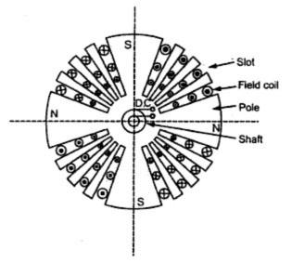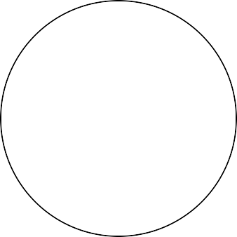

Normally 70% of the rotor is slotted and remaining portion is unslotted in order to form the pole. The design of the field can be explained as follows.

1. Selection of rotor slots: Total number of rotor slots may be assumed as 50 – 70 % of stator slots pitches. However the so found rotor slots must satisfy the following conditions in order to avoid the undesirable effects of harmonics in the flux density wave forms.
2. There should be no common factor between the number of rotor slot pitches and number of stator slot pitches.
3. Number of wound rotor slots should be divisible by 4 for a 2 pole synchronous machine. That means the number of rotor slots must be multiple of 4.
4. Width of the rotor slot is limited by the stresses developed at the rotor teeth and end rings.
5. Design of rotor winding
6. Full load field mmf can be taken as twice the armature mmf.

ATfl = 2 x ATa = 2 x 1.35 x Iph x Tph x kw /p

1. Standard exciter voltage of 110 - 220 volts may be taken. With 15-20 % of this may be reserved for field control. Hence voltage across each field coil Vf = (0.8 to 0.85) V/p
2. Length of the mean turn *l*mt = 2L + 1.8 τp + 0.25 m
3. Sectional area of each conductor *af* = ζ x *l*mt x (If x Tf) / vf
4. Assume suitable value of current density in the rotor winding. 2.5 – 3.0 amp/mm2 for conventionally cooled machines and 8 – 12 amp/mm2 for large and special cooled machines.
5. Find area of all the rotor conductors per pole = 2 x (If x Tf) /δf
6. Find the number of rotor conductors per pole = 2 x (If x Tf) / (δf x *af*)
7. Number of field conductors per slot = 2 x (If x Tf) / (δf x *af* x sr), where sr is the number of rotor slots.
8. Resistance of each field coil Rf = ζ x *l*mt x Tf / *af*
9. Calculate the current in the field coil If = vf/ Rf

Based on the above data dimensions may be fixed. The ratio of slot depth to slot width may be taken between 4 and 5. Enough insulation has to be provided such that it with stands large amount of mechanical stress and the forces coming on the rotor.

The following insulation may be provided for the field coil.

1. All field conductors are provided with mica tape insulation.
2. Various turns in the slots are separated from each other by 0.3 mm mica separators.
3. 0.5 mm hard mica cell is provided on all the field coil.
4. Over the above insulation, 1.5 mm flexible mica insulation is provided.
5. Lastly a steel cell of o.6 mm is provided on the whole field coil.

Ex. 1. Design the rotor of a 3 phase 20 MVA, 11 kV, 3000 rpm, 50 Hz, turbo alternator with the following design data. Diameter at the air gap = 0.8 m, Gross length = 2.4 m, stator turns per phase

= 18, Number of stator slots = 36, Exciter voltage = 220 volts, Estimate (i) Number of rotor slots,

(ii) area of the field conductor (iii) Turns in the filed coil and (iv) Field current

Soln: (i) Number of rotor slots : Selection of rotor slots: Total number of rotor slots may be assumed as 50 – 70 % of stator slots. Normally 70% of the rotor is slotted and remaining portion is unslotted.

Number of stator slots = 36

Hence number of slots pitches must be between 18 to 26 Satisfying the conditions number of rotor slot pitches = 23 Number of wound slots = 16

1. Area of the field conductor

Assuming 40 volts in the field regulator voltage across filed coil = 220 – 40 /2 = 90 volts Armature ampere turns /pole ATa=1. 35 Iph Tph Kw /p

= 1.35 x 1050 x 18 x 0.955/ 1 = 24300 AT

Assuming full load field ampere turns/pole = 2 x ATa = 2 x 24300 = 48600 AT Mean length of the turn is given by *l*mt = 2L + 1.8 τp + 0.25 m

= 2 x 2.4 + 1.8 x 1.256 + 0.25

= 7.31 m

Area of the field conductor *af* = ζ x *l*mt x (If x Tf) / vf

= 0.021 x 7.31 x 48600/90

= 83.22 mm2

1. Number of field turns : Full load field ampere turns/pole = 48600 AT Full load field ampere conductors/pole = 2 x 48600 AT

Assuming a current density of 2.6 amp/mm2

Area of all the rotor conductors = 2 x 48600 / 2.6 = 37400 mm2 Number of rotor conductors/pole = 37400/84 = 445

Number of wound slots per pole = 16/2 = 8 Number of conductors per slot = 445/8 = 56

Modified value of conductors per pole = 56 x 8 = 448 Number of field turns per pole Tf = 448/2 = 224 Number of coils per pole = 8/2 = 4

1. Field current: Resistance of the field coil *Rf* = ζ x *l*mt x Tf / *af*

= 0.021 x 7.31 x 224/ 84

= 0.41 Ω

Current in the field winding If = Vc/ *Rf* = 90/0.41 = 219 Amps.

## References

1. A Course in Electrical Machine Design – A. K. Sawhney
2. Design of Electrical Machines – V. N. Mittle
3. Performance and Design of A C Machines – M G Say
4. Design and Testing of Electrical Machines – M. V. Deshapande
5. Electrical Machine Design Data Book – Shanmugsundaram and Palani
6. [www.google.com](http://www.google.com/) and related websites
7. [www.phasemotorparts.com](http://www.phasemotorparts.com/)
8. [www.wikipedia.org](http://www.wikipedia.org/)
9. Krishna Vasudevan et. al. Electrical Machines II, Indian Institute of Technology, Madras